Personalized Networking Assistant

1. Introduction
• Project Title: Personalized Networking Assistant

S.No. | Team Member Name | Role
1 | - Satya Kalyani | Backend & AI Development
2 | - Venkata Kowshik | Frontend Development & UI Design
3 | - Sravanthi | API Integration, Testing & Debugging
4 | P.Baby Naga Lakshmi | Documentation, Validation & Presentation

2. Project Overview

Purpose
The Personalized Networking Assistant is an AI-powered web application designed to help users build meaningful professional and social connections. It generates personalized conversation starters based on event descriptions and user interests, making networking easier and more effective.
The application uses DistilBERT to identify important themes from event descriptions and GPT-2 to generate context-aware conversation suggestions. It also integrates the Wikipedia API for quick fact verification, allowing users to access reliable information before participating in networking events.
Additionally, the system maintains conversation history and collects user feedback to improve future recommendations. Built using FastAPI and Streamlit, the application provides a responsive, modular, and user-friendly experience.

Features
- AI-powered personalized conversation starter generation.
- Theme extraction using DistilBERT.
- Context-aware conversation suggestions using GPT-2.
- Quick fact verification through Wikipedia API.
- Conversation history management.
- User feedback system for improving recommendations.
- Interactive web interface developed using Streamlit.
- RESTful backend developed using FastAPI.
- Modular architecture with unit testing using pytest.
3. Architecture
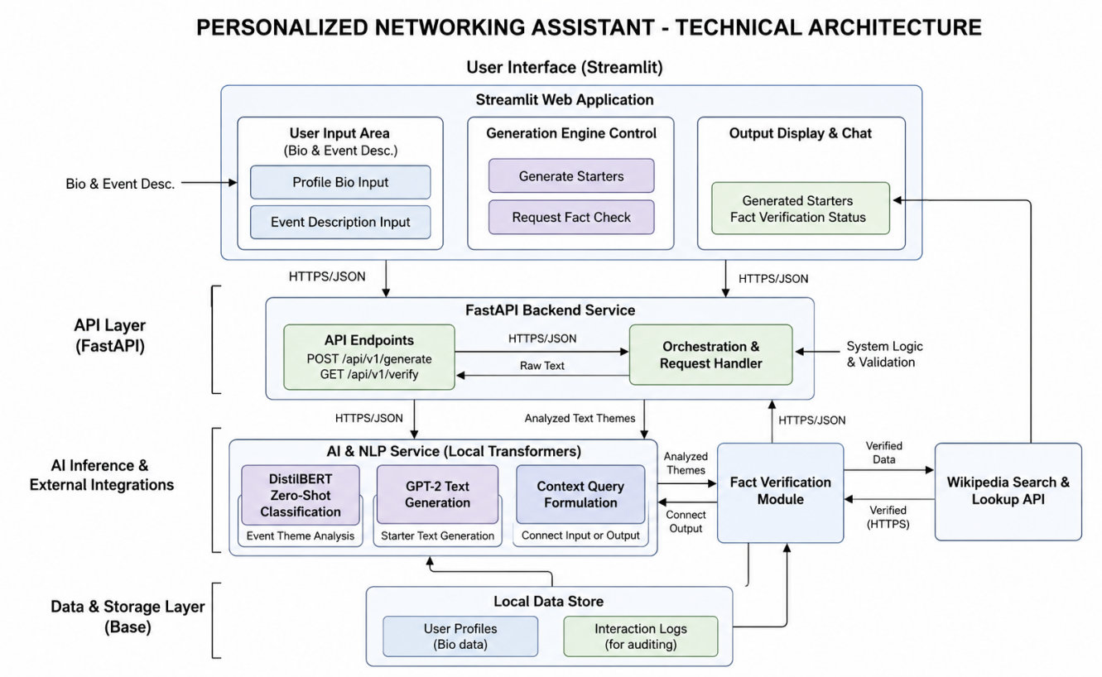
4. Setup Instructions

4.1 Prerequisites
Before starting the project, install the required software and tools listed below. A basic understanding of Python and Git is recommended.

Python 3.11+
Used to develop the application and run the backend services.
https://www.python.org/downloads/

FastAPI
Used to build the REST APIs that connect the frontend with the backend.
https://fastapi.tiangolo.com/

Streamlit
Used to create the web interface for user interaction.
https://docs.streamlit.io/

Hugging Face Transformers
Provides the DistilBERT and GPT-2 models used for AI-based text processing.
https://huggingface.co/docs/transformers/

PyTorch
Used to run the AI models in the application.
https://pytorch.org/docs/

Wikipedia API
Used to retrieve and verify factual information from Wikipedia.
https://pypi.org/project/wikipedia/

Git
Used to manage and track changes in the project source code.
https://git-scm.com/doc

Virtual Environment (venv)
Used to manage project dependencies in an isolated environment.
https://docs.python.org/3/library/venv.html

Visual Studio Code
Recommended code editor for developing and managing the project.
https://code.visualstudio.com/

4.2 Installation

Step 1: Create a Project Folder
Create a folder named Personalized-Networking-Assistant and place all the project files inside it.

Step 2: Create a Virtual Environment
python -m venv .venv

Step 3: Activate the Virtual Environment
Windows
.venv\Scripts\activate

Step 4: Install Required Packages

pip install fastapi uvicorn streamlit requests transformers torch wikipedia pydantic pytest python-dotenv

Step 5: Verify the Installation
Check that all required packages are installed.

4.3 Project Dependencies
Package | Purpose
FastAPI | Backend REST API
Streamlit | Frontend Web Interface
Transformers | DistilBERT and GPT-2 models
Torch | Deep learning framework
Requests | HTTP communication
Wikipedia | Fact verification
Pydantic | Data validation
pytest | Unit testing
python-dotenv | Environment variable management
- Folder Structure
The project is organized into separate folders for backend development, frontend implementation, AI services, API routes, testing, and configuration. This modular structure improves code organization, maintainability, and scalability.
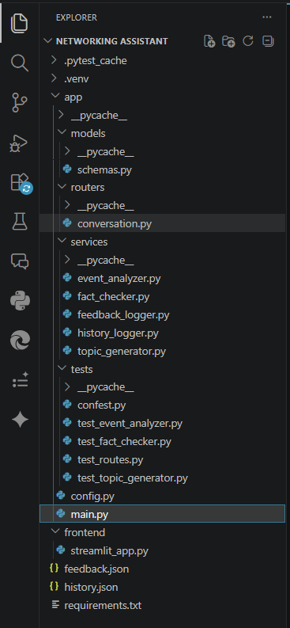

6. Running the Application
Follow the steps below to run the application locally.

Step 1: Activate the Virtual Environment
Windows
.venv\Scripts\activate

Step 2: Start the FastAPI Backend
Open a terminal in the project directory and run:
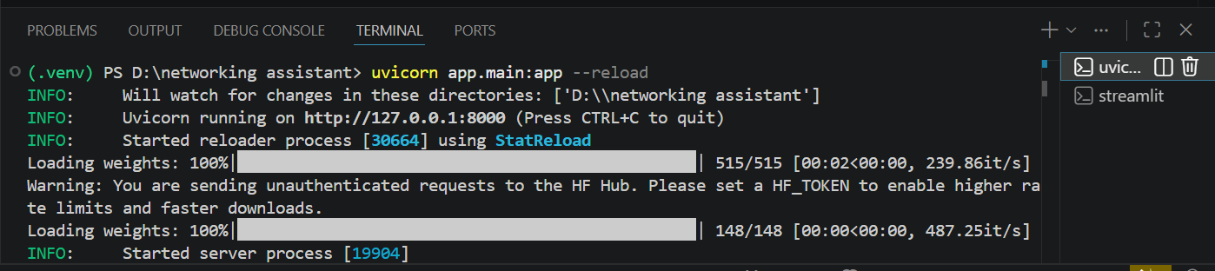
The backend server will start at:
http://127.0.0.1:8000
The interactive API documentation can be accessed at:
http://127.0.0.1:8000/docs

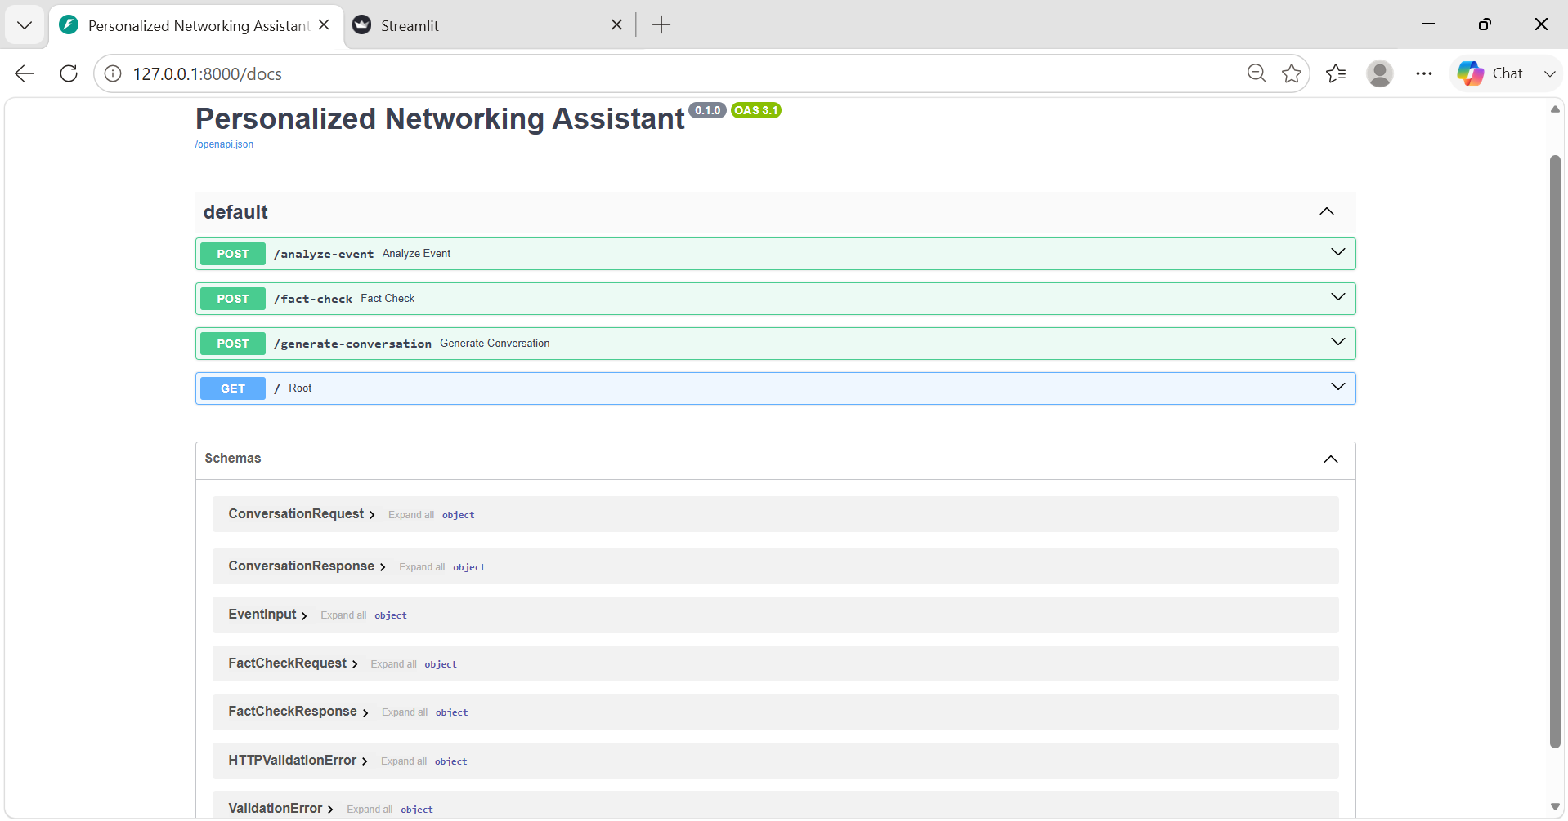

Step 3: Start the Streamlit Frontend
Open another terminal, activate the virtual environment, and run:
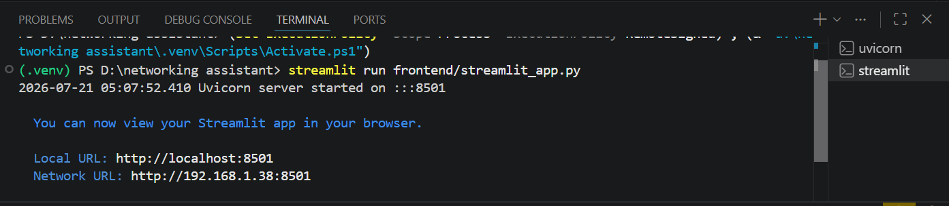
The application will open automatically in your default web browser.
If it does not open automatically, visit:
http://localhost:8501

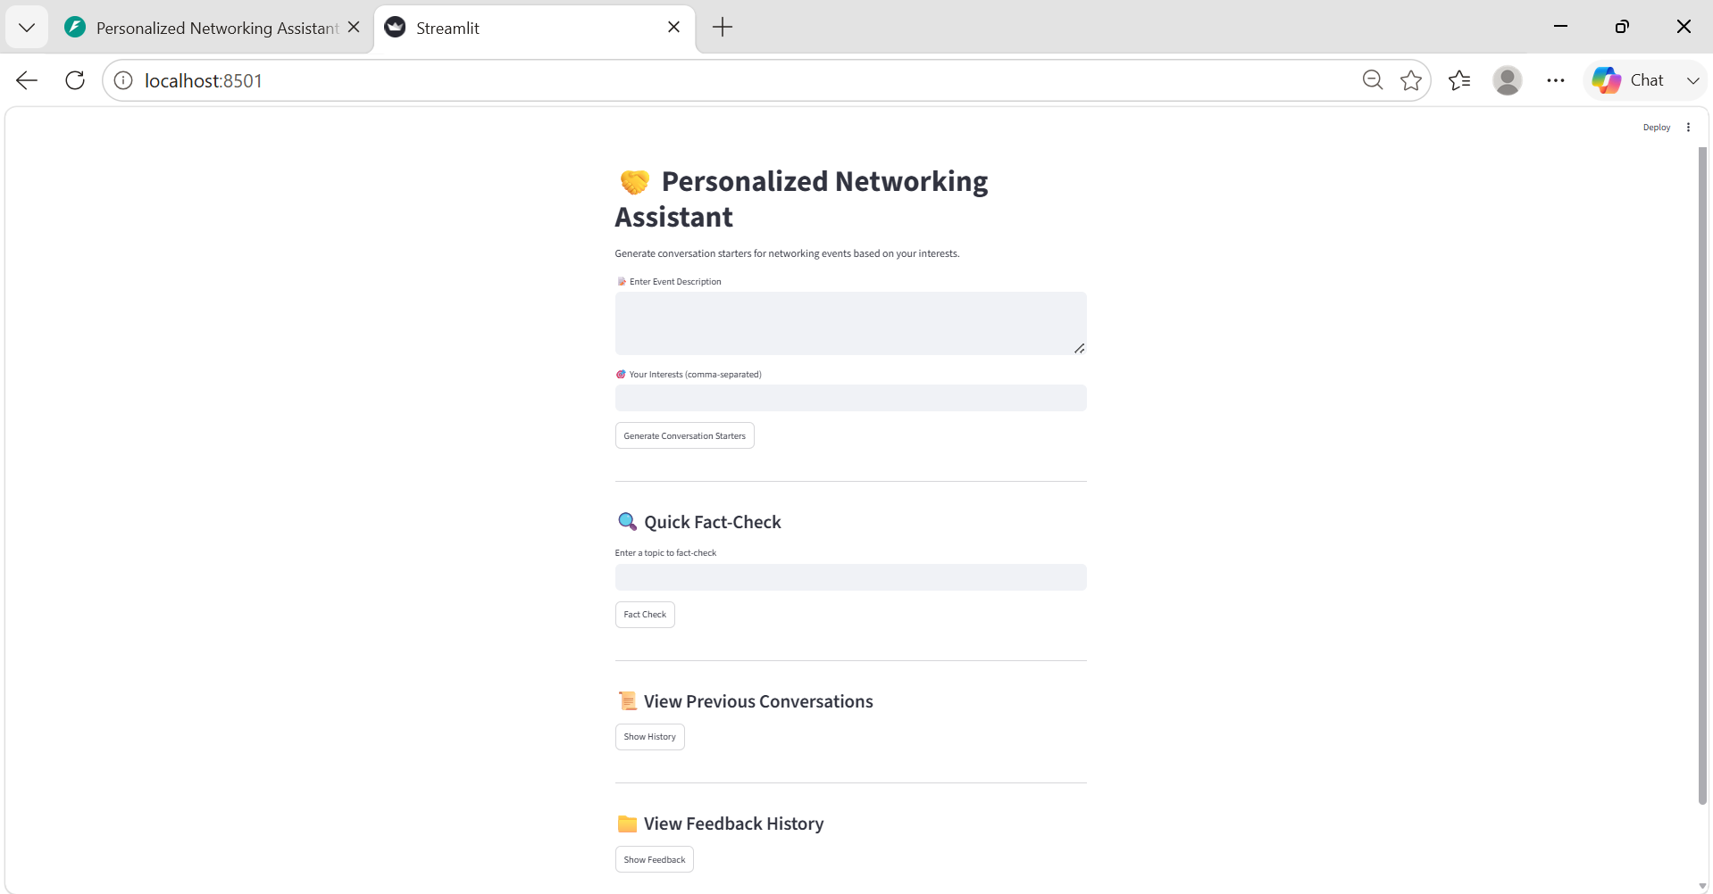

Step 4: Verify the Application
Verify that the application is running correctly by performing the following checks:
- The FastAPI backend is accessible at http://127.0.0.1:8000.
- The API documentation opens successfully at http://127.0.0.1:8000/docs.
- The Streamlit interface loads in the browser.
- Enter an event description and user interests.
- Generate conversation starters and verify that results are displayed successfully.
- Test the fact verification feature using a sample topic.
7. API Documentation
The backend is developed using FastAPI, which exposes REST APIs for theme extraction, conversation generation, and fact verification. The APIs communicate with the Streamlit frontend using JSON requests and responses.

API Endpoints
Endpoint | Method | Description
/analyze-event | POST | Extracts key themes from the event description using DistilBERT.
/generate-conversation | POST | Generates personalized conversation starters using GPT-2.
/fact-check | POST | Retrieves verified information from Wikipedia based on the user's query.

1. Analyze Event
Endpoint
POST /analyze-event
Sample Request
{
"event_description": "AI for Sustainable Cities"
}
Sample Response
{
"themes": [
"Artificial Intelligence",
"Sustainability",
"Urban Planning"
]
}

2. Generate Conversation
Endpoint
POST /generate-conversation
Sample Request
{
"event_description": "AI for Sustainable Cities",
"interests": [
"Climate Change",
"Urban Planning"
]
}
Sample Response
{
"conversation_starters": [
"How do you think AI can improve sustainable cities?",
"What recent innovations in urban planning interest you?",
"Have you worked on any smart city projects?"
]
}

3. Fact Verification
Endpoint
POST /fact-check
Sample Request
{
"query": "Blockchain in Healthcare"
}
Sample Response
{
"summary": "Blockchain technology is used in healthcare to securely store and share medical records while improving transparency and data integrity."
}
The APIs can be tested using:
- FastAPI Interactive Documentation (/docs)
- Swagger UI
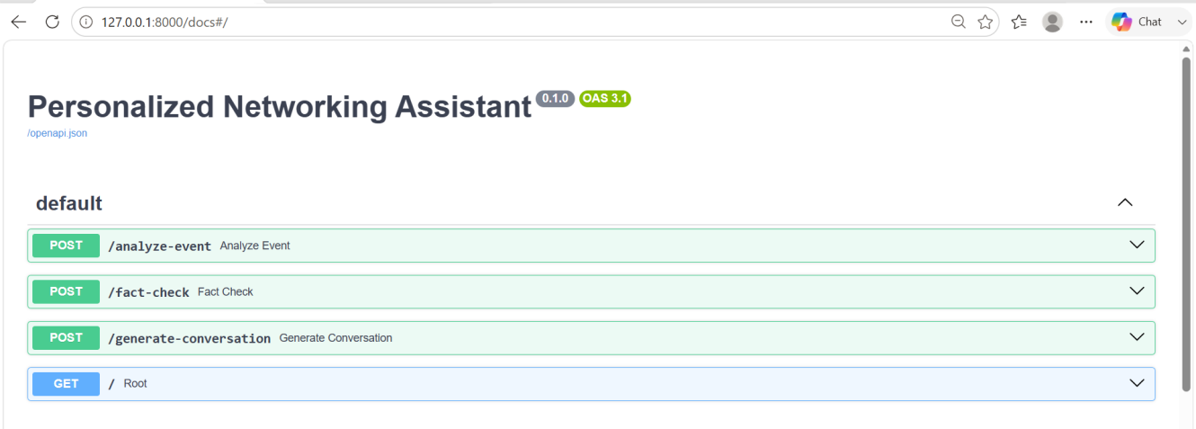
8. Authentication
The current version of the Personalized Networking Assistant does not implement a dedicated user authentication or authorization mechanism. Users can directly access the application and utilize its features without creating an account or logging in.
The application focuses on generating personalized conversation starters, performing fact verification, and maintaining conversation history locally. Since the project is intended as a prototype, user authentication has not been included.
In future versions, authentication mechanisms such as JWT (JSON Web Tokens), OAuth, or role-based access control can be integrated to provide secure user access and personalized data management.
9. User Interface

9.1 Home Page
The home page provides the main interface of the application. It allows users to access the networking assistant and navigate to its core features through a simple and user-friendly layout.


9.2 Event Description Input
This screen allows users to enter the event description and specify their interests. The provided information is used by the AI models to understand the context and generate personalized conversation starters.
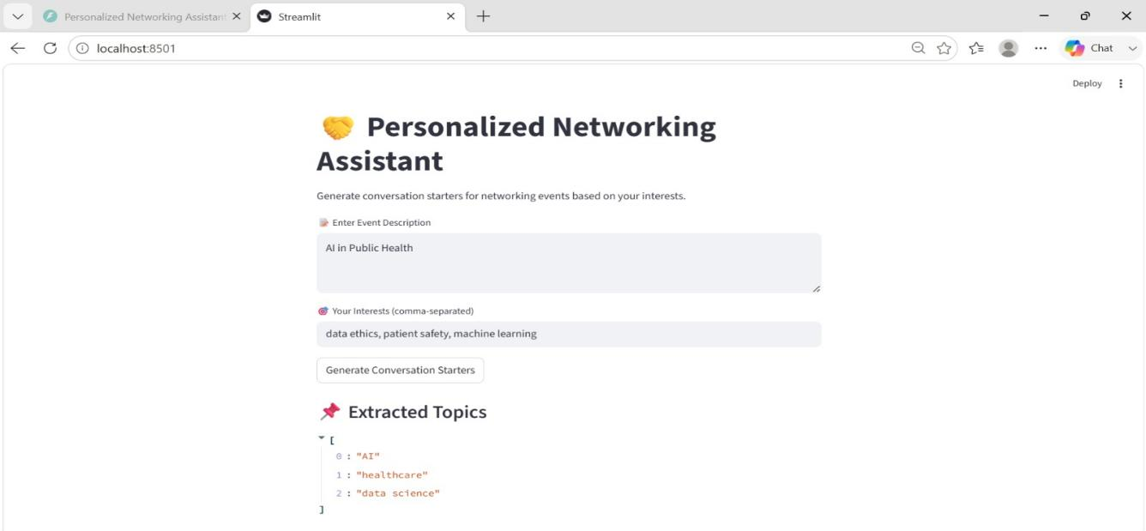

9.3 Generated Conversation Starters
This screen displays AI-generated conversation starters based on the event description and user interests. The suggestions help users initiate meaningful and relevant conversations during networking events.
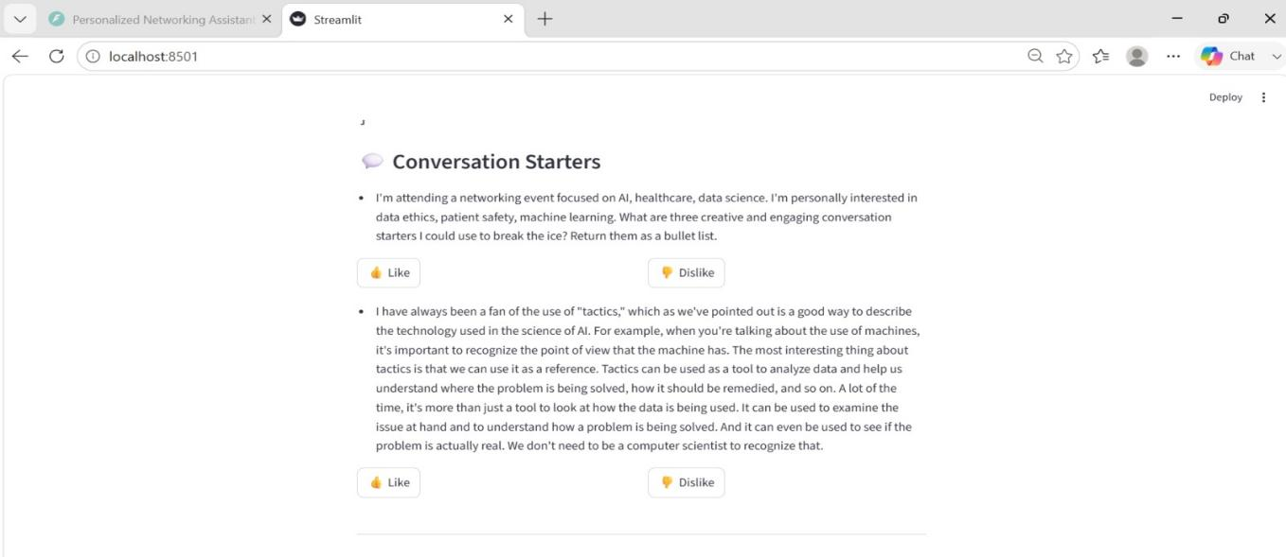

9.4 Fact Verification
The fact verification feature enables users to search for reliable information on a topic. The application retrieves concise summaries using the Wikipedia API to help users prepare for discussions.
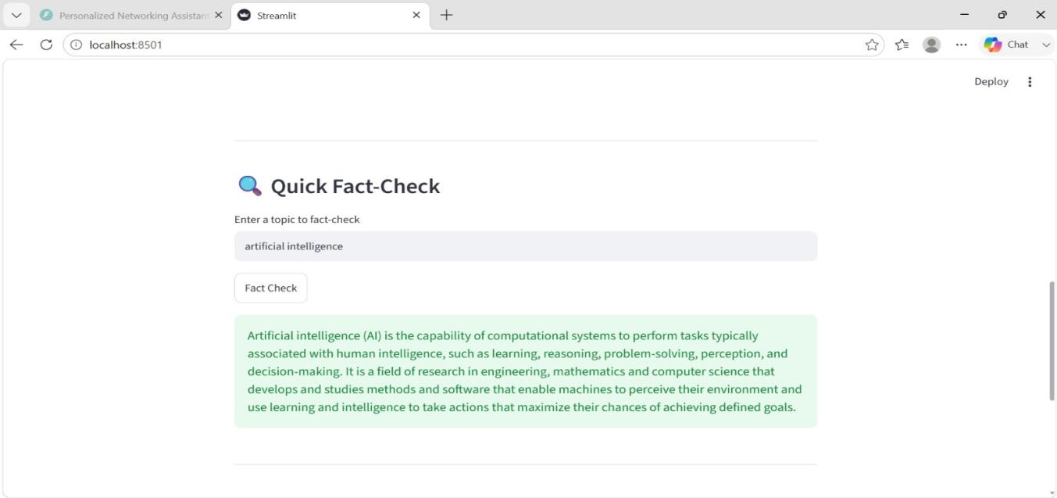

9.5 Conversation History
This screen displays previously generated conversation starters, allowing users to review and reuse past suggestions for future networking opportunities.

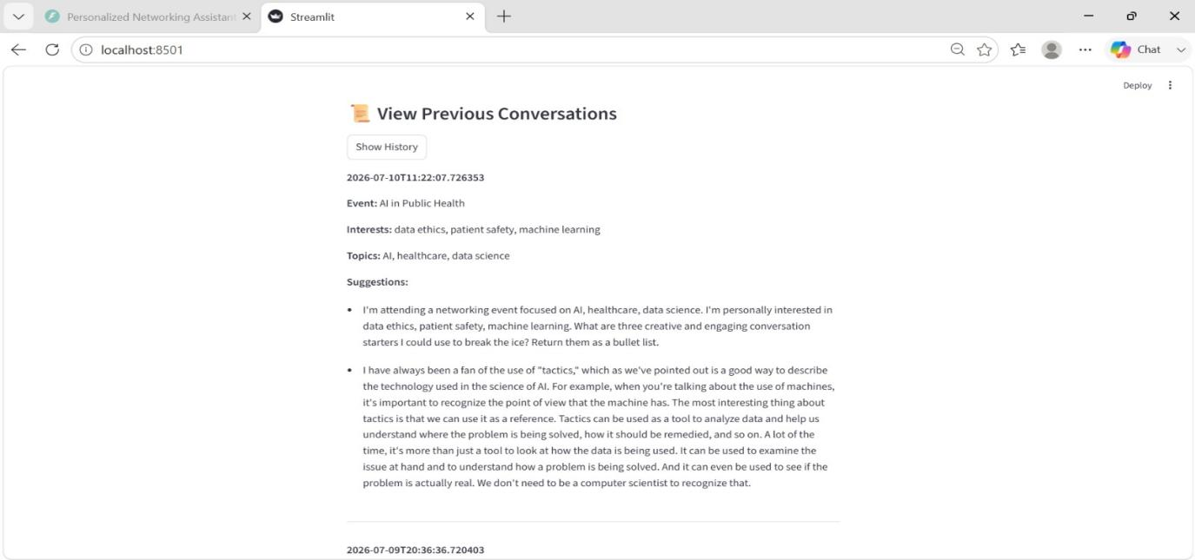

9.6 Feedback Feature
The feedback feature allows users to rate the usefulness of the generated conversation starters. User feedback helps evaluate the quality of suggestions and supports future improvements to the application.
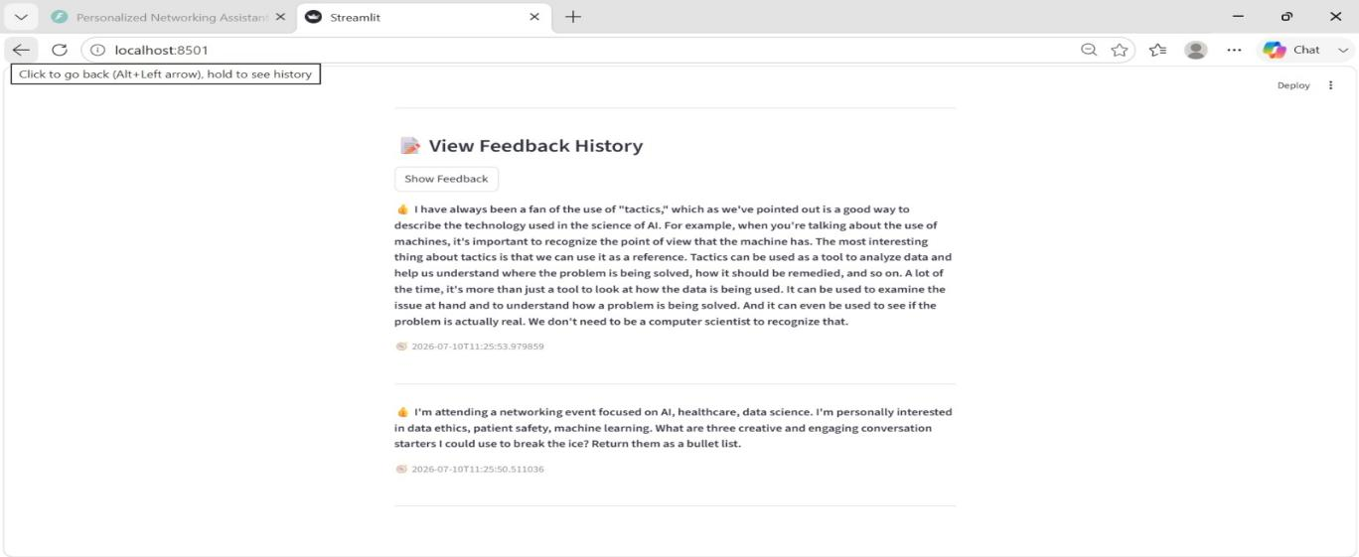
10. Testing
The Personalized Networking Assistant was tested using pytest to verify the correctness of the backend services and API endpoints. Unit testing was performed to ensure that each module functions as expected and returns accurate results.
The testing process focused on validating the AI services, API routes, and fact verification functionality.

Testing Tool
- Framework: pytest
- Testing Type: Unit Testing

Test Cases
Test File | Purpose
test_event_analyzer.py | Tests theme extraction from event descriptions.
test_topic_generator.py | Tests generation of personalized conversation starters.
test_fact_checker.py | Tests fact verification using the Wikipedia API.
test_routes.py | Tests FastAPI API endpoints and responses.

Test Results
The implemented test cases were executed successfully using pytest. The tests verified:
- Correct extraction of event themes.
- Successful generation of conversation starters.
- Accurate fact verification responses.
- Proper API request and response handling.
All core modules functioned as expected during testing.
11.Demo
The complete working demonstration of the Personalized Networking Assistant is available at the following link:
Demo Video: https://drive.google.com/file/d/1MXn1Dxl2PmLiMAaqK5knI7bvCfZK3pI8/view?usp=drivesdk
Description:
The demo illustrates the complete functionality of the application, including theme extraction, AI-generated conversation starters, fact verification, conversation history, and the feedback mechanism.

12. Known Issues
The current version of the Personalized Networking Assistant has a few limitations that can be improved in future releases.
- The application requires an internet connection for fact verification using the Wikipedia API.
- AI-generated conversation starters may occasionally produce generic or repetitive responses.
- Theme extraction accuracy depends on the quality and detail of the event description provided by the user.
- The application currently supports a single-user environment and does not include user authentication.
- Conversation history and feedback are stored locally, making them unavailable across different devices.
- Performance may be slower on systems with limited processing power when loading AI models.

13. Future Enhancements
The following features can be added to improve the functionality of the application in future versions:
- Implement secure user authentication and profile management.
- Support cloud database integration for storing user history and preferences.
- Add support for multiple AI models to improve conversation quality.
- Integrate additional fact-checking sources beyond Wikipedia.
- Provide multilingual conversation starter generation.
- Recommend networking contacts based on user interests and event topics.
- Deploy the application on cloud platforms for online access.

Conclusion
The Personalized Networking Assistant is an AI-powered web application that helps users improve their networking experience by generating personalized conversation starters and providing quick fact verification. It uses DistilBERT, GPT-2, FastAPI, and Streamlit to deliver relevant and user-friendly networking support.
The project successfully meets its objectives by helping users prepare for networking events, build confidence, and communicate more effectively. With future enhancements such as user authentication, cloud deployment, and improved personalization, the application can become even more useful and efficient.

